**Operating Systems – COC 3071L**

**SE 5th A – Fall 2025**

# Lab 4: Introduction to Threads

## 1. Introduction to Threads

**1.1 What is a Thread?**

A **thread** is the smallest unit of execution within a process.

A **process** can have multiple threads running concurrently

All threads within a process share:

Memory space (code, data, heap)

File descriptors

Process ID

Each thread has its own:

Thread ID (TID)

Stack

Program counter

Register set

**Real-world analogy:**

**Process** = A restaurant kitchen

**Threads** = Multiple cooks working together in the same kitchen, sharing ingredients and equipment

### 1.2 Threads vs Processes – Quick Comparison

|  |  |  |
| --- | --- | --- |
| **Feature** | **Process** | **Thread** |
| Memory | Separate memory space | Shared memory space |
| Creation | Expensive (fork) | Lightweight (pthread_create) |
| Communication | IPC needed (pipes, etc.) | Direct (shared variables) |
| Context Switch | Slower | Faster |
| Independence | Fully independent | Dependent on parent process |

**When to use threads?**

When tasks need to share data frequently

For parallel execution within the same application

When you need lightweight concurrency

## 2. POSIX Threads (pthreads) Library

In Linux, we use the **POSIX threads (pthreads)** library for thread programming.

### 2.1 Compilation Requirements

When compiling programs with threads, you **must** link the pthread library:

The

-

lpthre

a

d

flag links the pthread library.

g

cc

progr

a

m

.

c

-

o

progr

a

m

-

lpthre

a

d

## 3. C Programs with Threads

### Program 1: Creating a Simple Thread

**Objective:** Create a thread and print messages from both main thread and new thread.

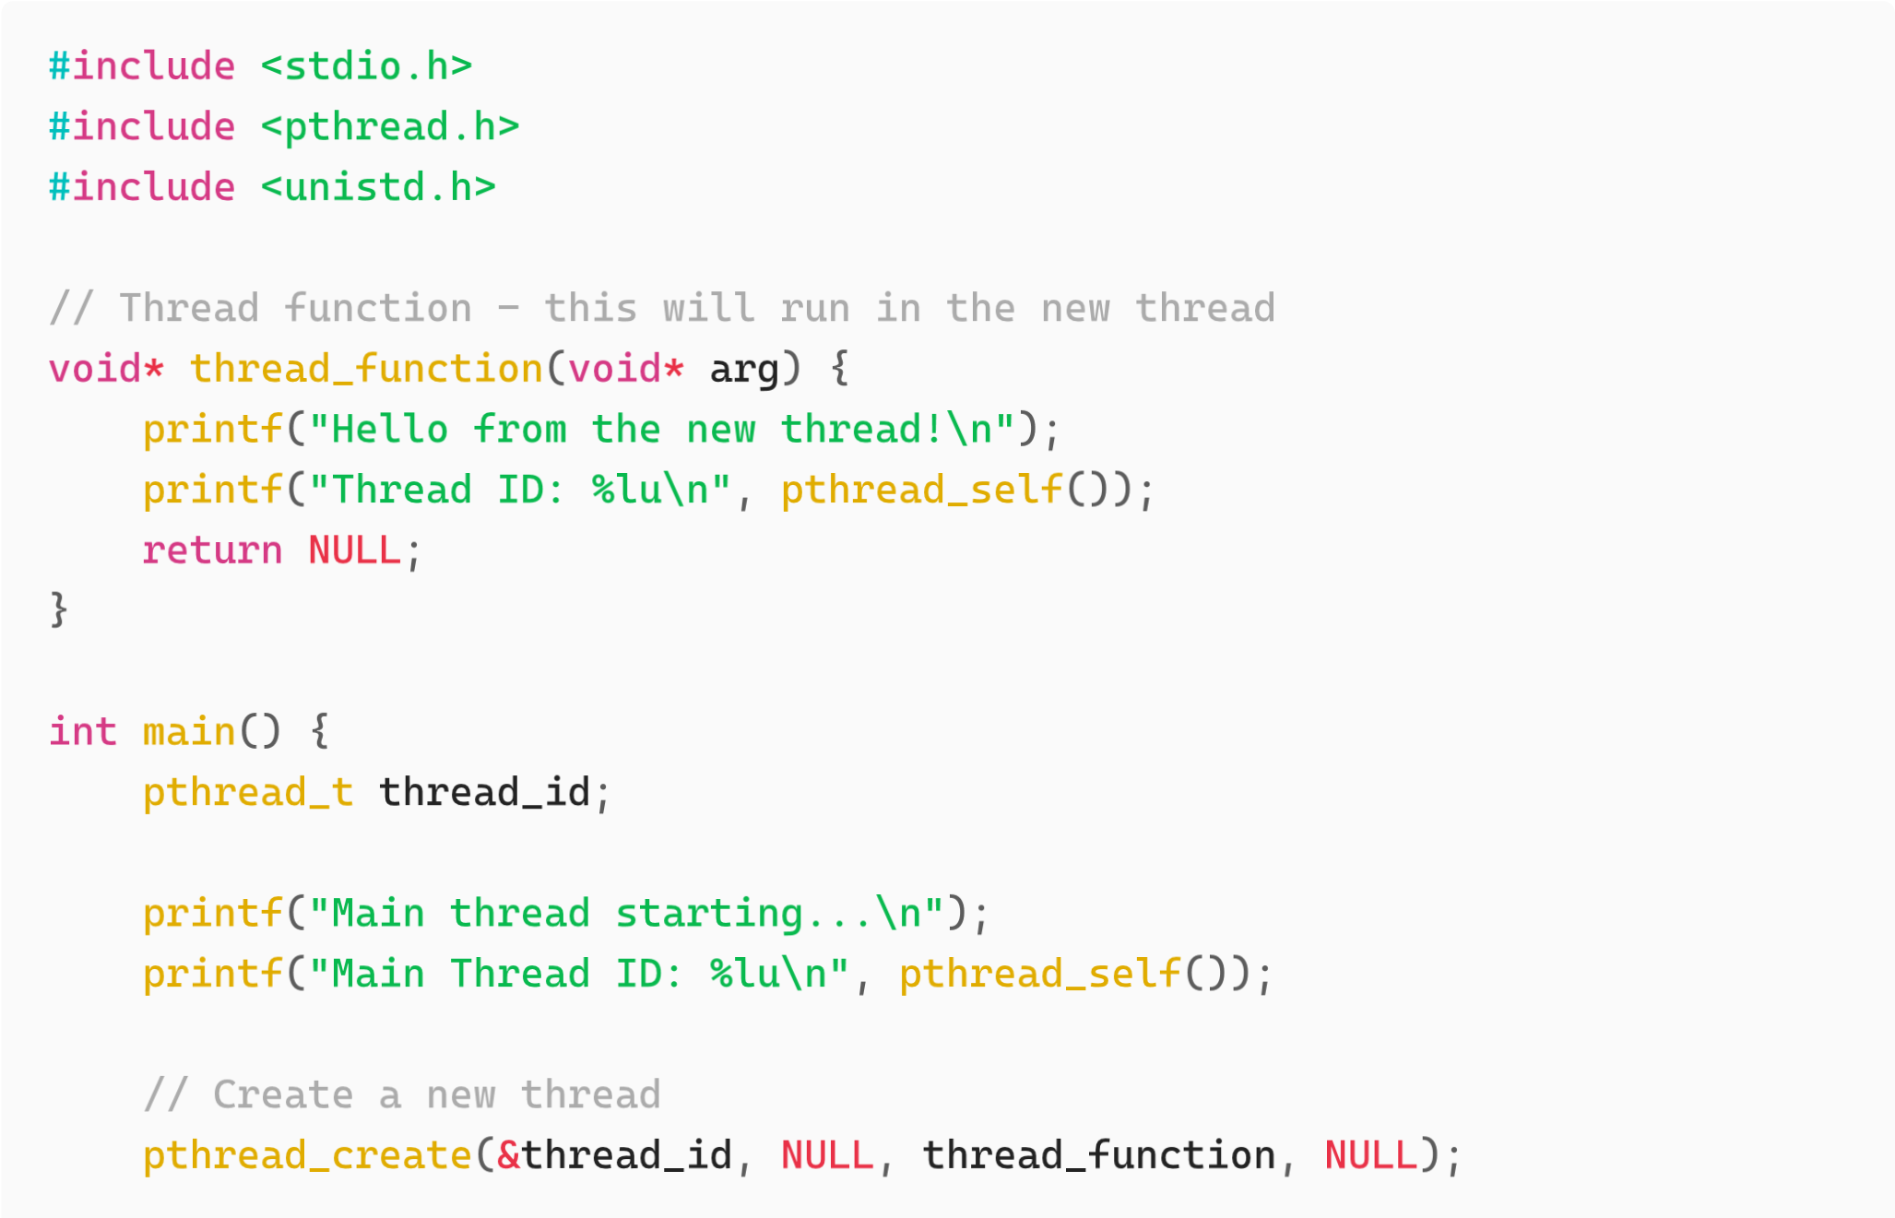

//

Wa

it

for

the

thre

a

d

to

finish

pthre

a

d

_

join

(

thre

a

d

_

id

,

NULL

)

;

printf

(

"

Ma

in

thre

a

d

exiting

...\

n

"

)

;

return

0

;

}

**Compile and run:**

g

cc

thre

a

d

1

.

c

-

o

thre

a

d

1

-

lpthre

a

d

./

thre

a

d

1

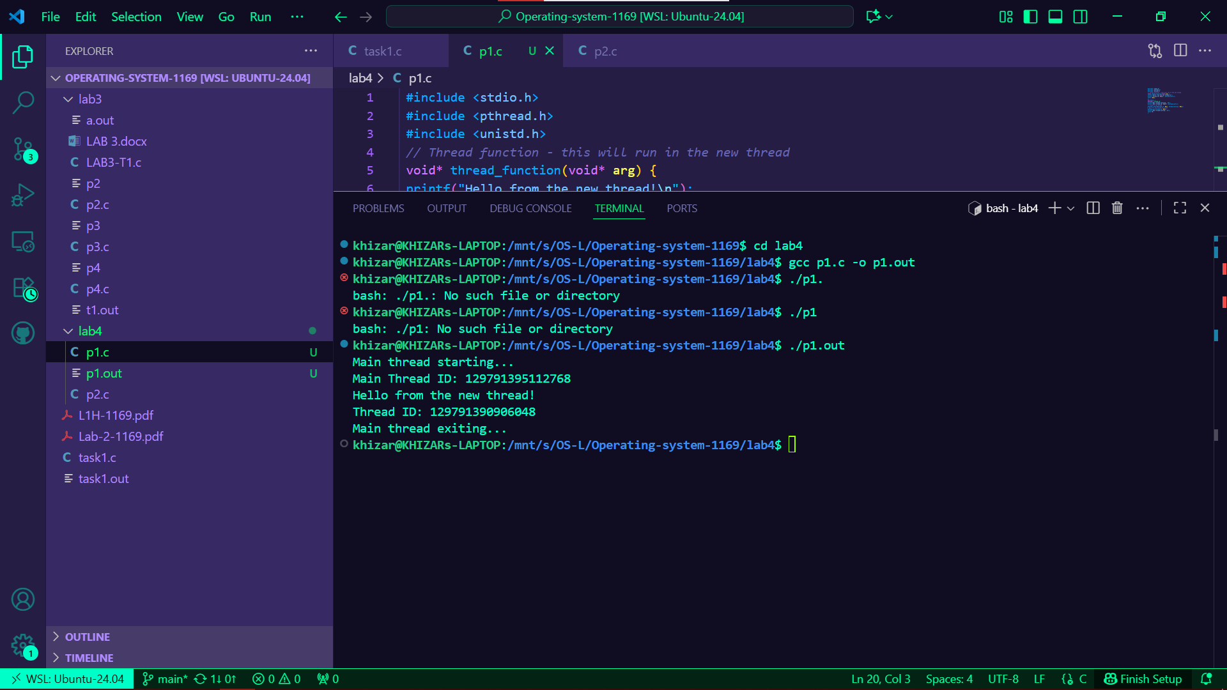

**Explanation:**

**pthread_t thread_id**

This creates a **variable** to hold the thread’s ID (like a file descriptor or process ID).

It’s just a handle the OS uses to manage the thread.

#### pthread_create(&thread_id, NULL, thread_function, NULL)`

Let’s decode the four parameters:

|  |  |  |
| --- | --- | --- |
| **Parameter** | **Type** | **Meaning** |
| &thread | pthread_t* | Where the new thread ID will be stored |
| NULL | pthread_attr_t* | Thread attributes (priority, stack size, etc.)  — NULL means default |
| myThread | void* (*start_routine) (void*) | Function to run in the new thread |
| NULL | void* | Pointer passed to the function for data |

pthre

a

d

_

join

()

→ Waits for thread to finish (like

w

a

it

()

for processes)

pthre

a

d

_

self

()

→ Returns the thread ID of calling thread

### Program 2: Passing Arguments to Threads

**Objective:** Pass data to a thread function.

#

in

c

lude

<

stdio

.

h

>

#

in

c

lude

<

pthre

a

d

.

h

>

void

*

print

_

num

b

er

(

void

*

a

rg

)

{

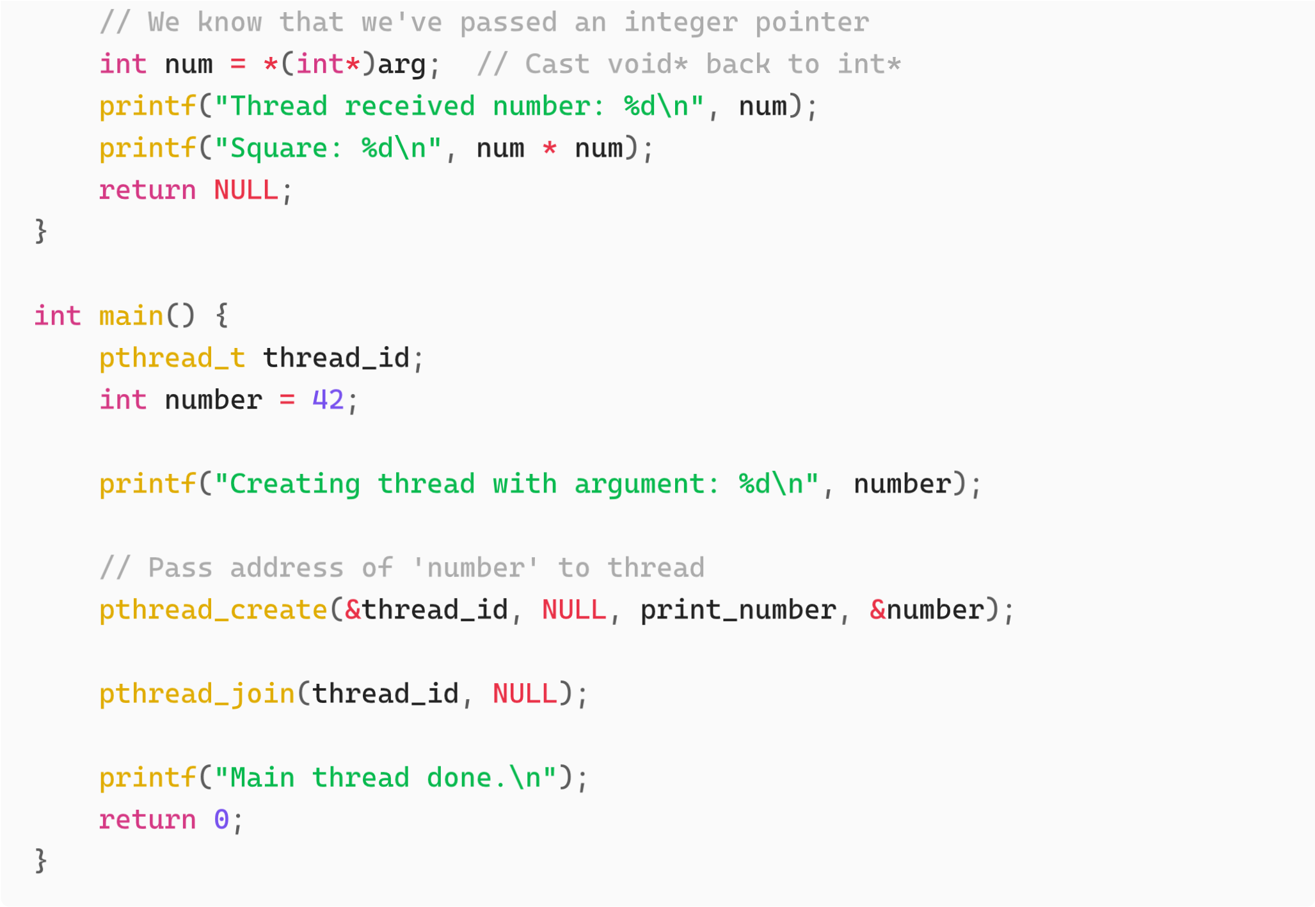

**Compile and run:**

g

cc

thre

a

d

2

.

c

-

o

thre

a

d

2

-

lpthre

a

d

./

thre

a

d

2

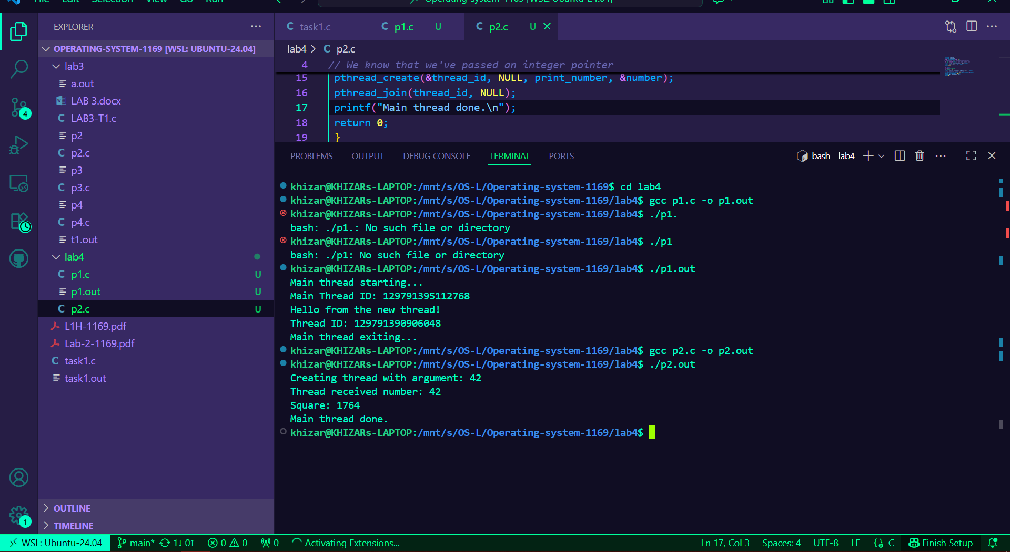

**Important Notes:**

The 4th argument of pthread_create() is passed to the thread function

It's a void* pointer, so you can pass any data type

Remember to cast it properly inside the thread function Here’s what happens step by step:

**Why use**

**void**

**\***

int

v

a

lue

=

*

(

int

*

)

a

rg

;

1

.

(

int

*)

a

rg

— cast

void

*

back to

int

*

.

.

2

*(

int

*)

a

rg

— dereference the pointer to get the integer value it points to.

The thread function must have the **standard signature**:

void

*

fun

c

tion

_

n

a

me

(

void

*

a

rg

)

That’s because threads can accept *any* data type — integers, structs, arrays, etc.

void* acts like a universal pointer type.

If you need to pass multiple variables, you wrap them in a

stru

c

t

and pass a pointer to it.

### Program 3: Passing Multiple Data

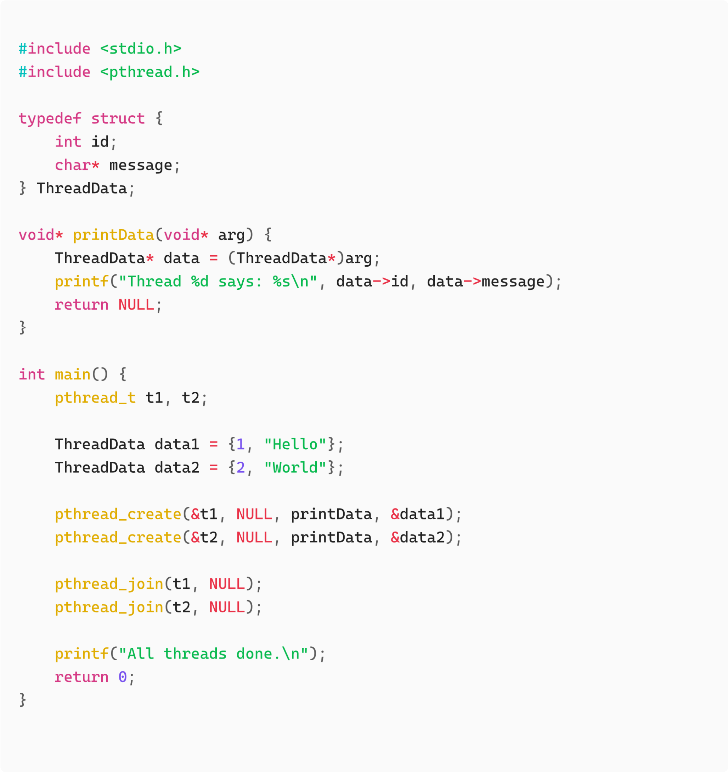

### Program 4: Multiple Threads

**Objective:** Create multiple threads executing the same function.

#

in

c

lude

<

stdio

.

h

>

#

in

c

lude

<

pthre

a

d

.

h

>

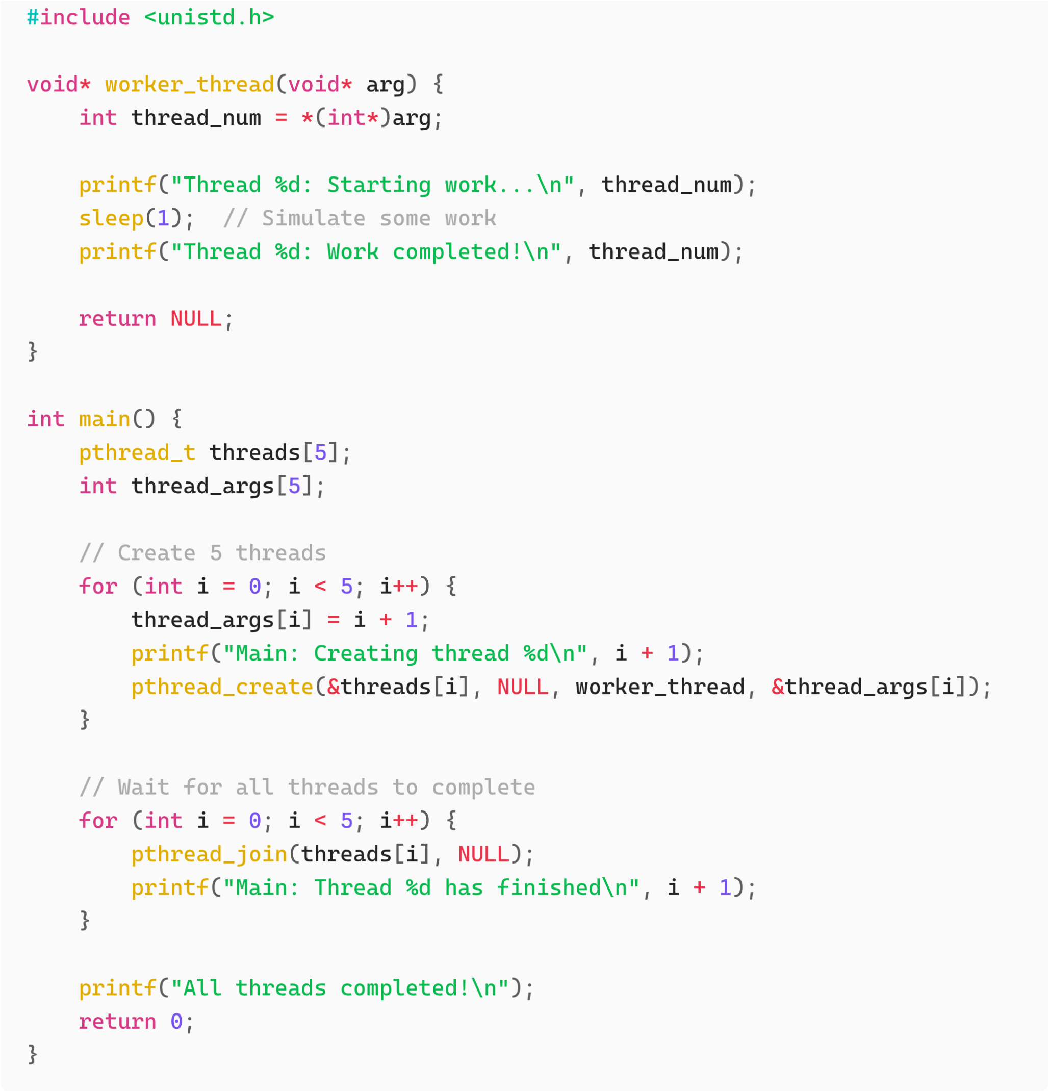

**Compile and run:**

g

cc

thre

a

d

3

.

c

-

o

thre

a

d

3

-

lpthre

a

d

./

thre

a

d

3

**Observation:**

Notice how threads may not execute in order

All threads run concurrently

pthre

a

d

_

join

()

ensures we wait for all threads

### Program 5: Thread Return Values

**Objective:** Get return values from threads.

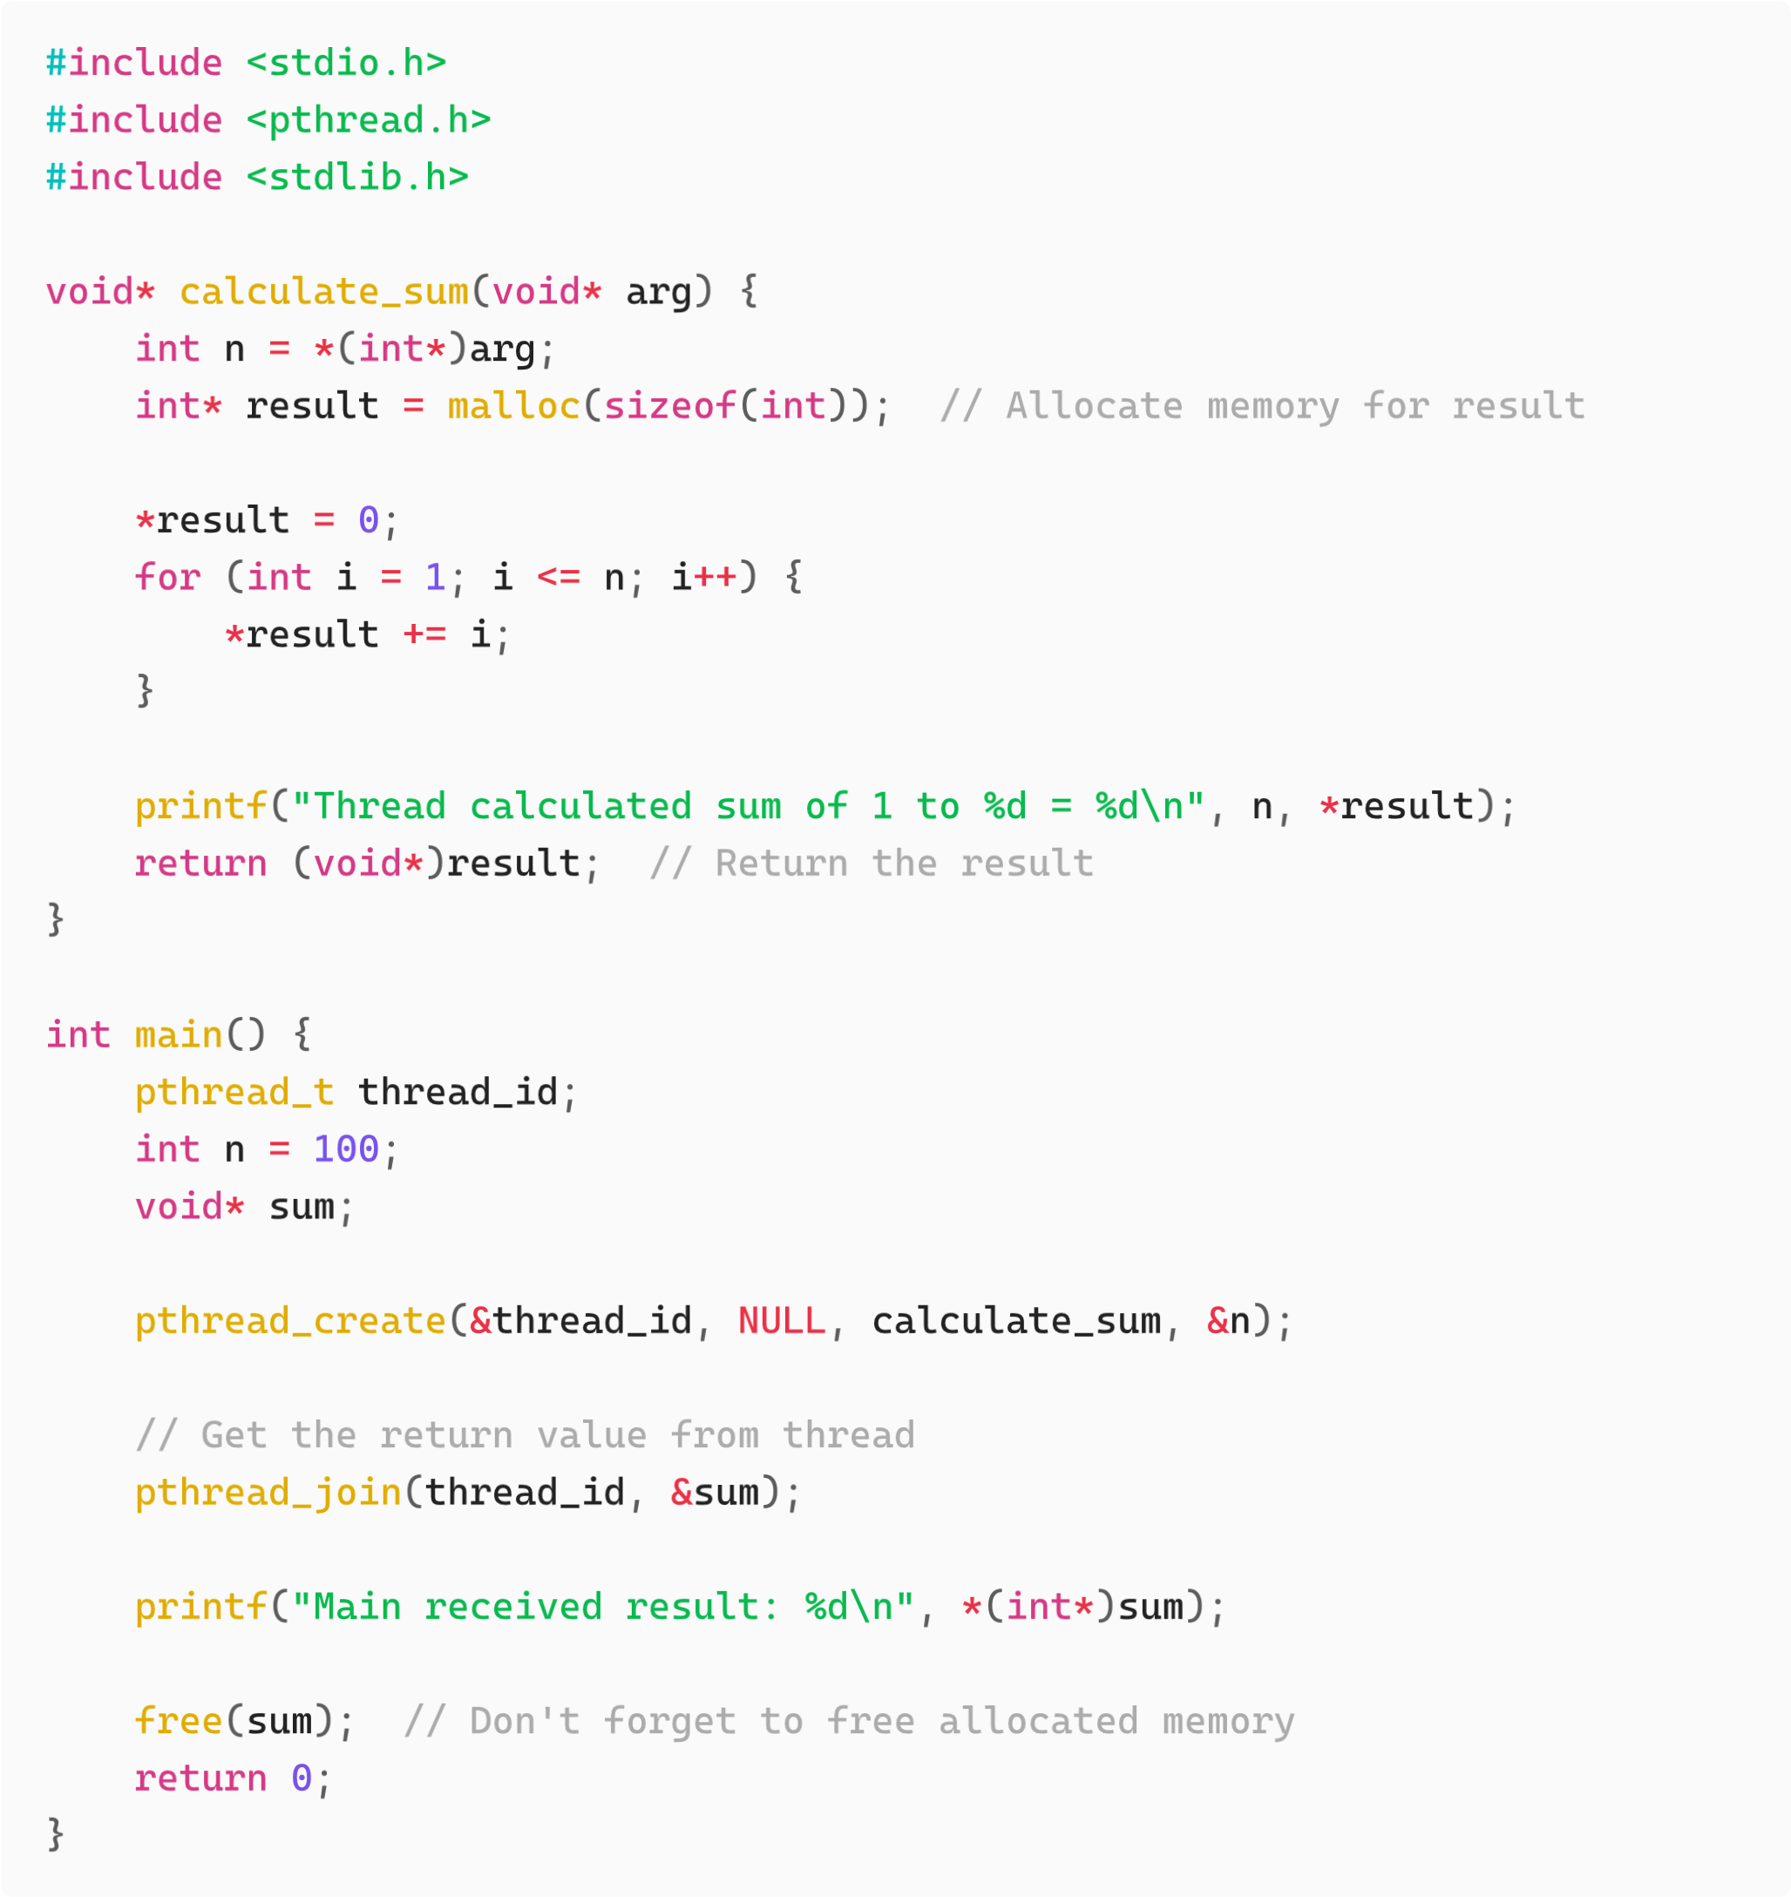

**Compile and run:**

g

cc

thre

a

d

4

.

c

-

o

thre

a

d

4

-

lpthre

a

d

./

thre

a

d

4

**Key Points:**

Thread functions return void*

Use pthread_join() to retrieve the return value

Remember to free any dynamically allocated memory

## 5. Hands-on Practice Exercises

### Exercise 1: Thread Basics

Write a program that:

1. Creates 3 threads
2. Each thread prints its thread ID and a unique message
3. Main thread waits for all threads to complete

### Exercise 2: Prime Number Checker

Write a program that:

1. Takes a number as input
2. Creates a thread that checks if the number is prime
3. Returns the result to the main thread
4. Main thread prints whether the number is prime or not